Peak Oil Media Guide
Last revised: July 6, 2008
This is a short summary of important concepts about peak oil and world oil production, prepared for the benefit of the media.

It’s not the size of the tank which matters, but the size of the tap.
Peak oil is not about “running out of oil,” it’s about the peak rate of oil production. It’s not the size of the tank which matters, but the size of the tap.
When the production rate of oil reaches its geological limit and begins to decline, the world’s economies will be forced to live within a shrinking, not expanding, energy budget. The economic impact of peaking oil production is what concerns us, not the amount of oil yet to produce. We won’t “run out of oil” for another 100 years or more, but it will be produced at ever-declining rates.
This is an essential concept. Talking only about the number of barrels of oil that might exist somewhere, without also talking about the rate at which that oil can be produced, and when, entirely misses the target.
Oil production rates generally follow an irregular bell-curve shape. It is simply the nature of petroleum extraction that it ramps up to a peak or short plateau, occasionally reaching a secondary peak, and then declines.. This observation has been made in thousands of oil fields (and oil producing nations) worldwide, and is named “Hubbert’s Peak” in honor of the geologist who first described it, Dr. M. King Hubbert.
For the world, ASPO-Ireland’s working model of past and future oil production looks like this:
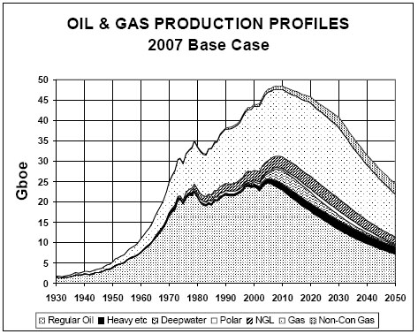
Figure 1 ASPO-Ireland World Oil Production Model
Source: Colin Campbell, ASPO-Ireland Newsletter No. 90 – June 2008
This model is based upon a detailed study of all the world’s major oil fields, with all forms of petroleum taken into account.
According to the June 2008 revision of this model, the peak of all petroleum liquids—including heavy oil from Venezuela, deepwater oil from the Gulf of Mexico, oil from the Arctic and Alaska, and natural gas liquids—is this year, 2008. But the exact date of the peak is almost irrelevant when considering the implications of peak oil.

We are now at, or “close enough” to the peak.
Right now, the world is producing between 86 and 87 million barrels per day (mbpd) of oil, and that rate has changed little since 2005. The world has reached a bumpy production plateau, as shown in the following chart.
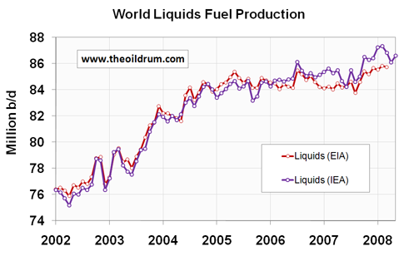
Figure 2 World Liquids Fuel Production January 2002 - May 2008
Source: Oilwatch Monthly, June 2008.
After a serious review of the flow rates of the world’s oil producers, we conclude that world production is unlikely to ever exceed 90 mbpd, and in fact, might not increase more than 1 or 2 million barrels above where it now stands. It appears we are now on the peak oil plateau, or close enough to it that the date of the technical, absolute peak doesn’t matter.
As ASPO founder Colin Campbell has said, “Arguing endlessly over the precise date of the peak also rather misses the point, when what matters is the vision of the long slope that comes into sight on the other side of it.”
Within the next three to six years, the world will likely reach the end of the peak oil plateau and go into terminal oil production decline.
At that point a growing world population will be forced to live with an ever-decreasing supply of oil. Many of the adaptation strategies we are counting on, like increasing the share of renewable energy and replacing the vehicle fleet with more efficient vehicles, will require decades and enormous investment to make much difference.
Unfortunately the world no longer has decades to make the necessary changes. Not only are we “close enough” to the peak, we’re far too close to it.

Oil production in the U.S. is well past its peak and is in long-term decline
The U.S. uses about 20+ mbpd of petroleum, and produces about 7 of that. The other two-thirds is imported. There is no possible way that we could produce another 13 million barrels per day domestically, no matter where or how quickly we drilled.
The potential flow rates of the remaining U.S. deposits are formally unknown (we’ll get to that in a moment), but their contribution cannot fundamentally change the basic trend line of our petroleum production. Here is a chart of historical U.S. oil production:
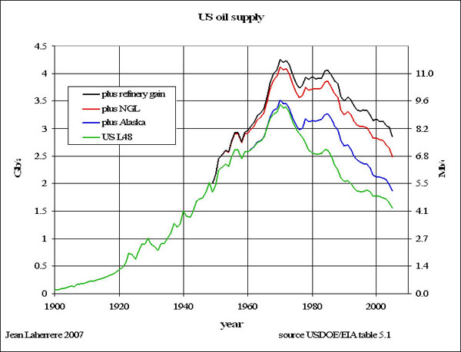
Figure 3 - US Oil Production 1900-2005
Source: Jean Laherrère

The 38-year decline in U.S. oil production was not the result of politics. It is simply the nature of petroleum extraction.

Oil shale: the fuel of the future…and it always will be.
After four decades of fully authorized, commercial, even subsidized attempts to develop oil shale into a usable liquid fuel, no one has ever been able to make it economically feasible. Part of the reason for that is that it’s not even really oil—it’s kerogen, an immature precursor to oil. Kerogen is a solid, like a low-grade, high-ash coal.
The most ambitious oil shale project in the country is a pilot project in northwest Colorado operated by Shell. Their plan is to drill several hundred holes into a football-sized plot of land, into which heating elements are inserted. They will heat up the “pay zone” of hydrocarbons, which is often buried 2000-4000 feet deep, to temperatures up to 700 degrees F, and keep it there for three to four years in order to cook the kerogen into a liquid.. That takes a great deal of energy input.
In order to keep the heated zone from leaking oil into the surrounding water table, a “freeze wall” is built around it, which will use even more energy to freeze the ground with giant chillers.
The net energy of this process isn’t yet known, but it’s so energy-intensive that we’re willing to bet this technology is unlikely to ever produce more than a modest flow (though perhaps a very long-lived one) of extremely expensive synthetic oil.
ASPO’s Randy Udall puts it this way: “Suppose you owned $100 million dollars, but the bank would only allow you to withdraw $100,000/year. You would be rich…sort of.”

ANWR and the continental shelf are no panacea.
The potential flow rates of the conventional sources of hydrocarbons locked up in ANWR and the continental shelf cannot be known until they are produced. But we can make ballpark estimates.
All of these areas have been well explored, and we have an idea of what they might produce: a slight bump in the bell curve of U.S. oil production, like this:
Figure 4 –US Oil Production 1860-2100
Historical data (1860-2006, red symbols) and model predictions for US oil production rates in billion barrels per year. - Dashed line: Base case with 231 billion barrels ultimate cumulative US oil production. - Solid line: Production curve with 42 billion barrels of new oil resources (273 billion barrels of ultimate cumulative production).
Source: Dr. Kyriacos Zygourakis, Rice University, “Commentary: On Quenching Our “Big Thirst” for Oil,” Peak Oil Review, May 5, 2008.
That model is a best-case scenario of US oil production if all off-limits federal lands were opened to drilling.
There are limits on all of the remaining U.S. oil reserves, for numerous technical reasons that would be beyond the scope of this summary. To cite just one example, let’s look at the capacity of the Arctic National Wildlife Refuge (ANWR).
There is only one pipeline that could transport oil from ANWR: the 800-mile Trans Alaskan Pipeline System (TAPS), which serves the Prudhoe Bay field. No other oil pipeline from Alaska’s north slope would ever be built, due to the cost and logistical issues. TAPS can transport a little over 2 mbpd, and carried about 740,000 bpd last year. Therefore, if we brought ANWR online today, it could at maximum deliver about 1.25 mbpd. But in reality, it would take 8-10 years after approval to begin producing the first of that oil. Furthermore, preliminary estimates by the USGS indicated that ANWR would likely only produce around 750,000 barrels per day at peak.
If we are currently on the peak/plateau of global oil production, and production starts to fall within the next five years, then 10 years from now, at a reasonable average 2.0% rate of net depletion, world oil production will be down 11 mbpd—about 12%—from where it stands today.
In total, we believe that if all limits on domestic drilling were removed, it could only increase US oil production by a maximum of 2-3 mbpd. Once it came online bit by bit, given the loss in global oil production by that time, the additional oil from ANWR and all other undeveloped federal lands will be underwhelming..
The U.S. Department of Energy estimates that drilling in ANWR would only reduce the price of gasoline by less than four pennies per gallon—20 years from now!
The idea that we can somehow drill our way to independence from imported oil is, unfortunately, misleading in the extreme. At the rate that the U.S. currently uses oil, the chance of producing all of our own needs domestically is zero. The only way we can become energy independent is by severely curtailing our oil demand.
Indeed, we should recognize, as the Saudis have, that the oil that remains will only become more valuable as time goes on, and it makes sense to save some for future generations. Burning every last bit of it as quickly as we can makes no sense at all.

Oil prices aren’t all about us.
It’s an all-too-common belief that if only we had authorized more domestic development of oil, our gasoline prices would be lower.
Even though we are the proverbial 8,000 pound gorilla, consuming about one-quarter of the world’s energy, oil prices are not all about us. The increasing consumption of countries in Asia, South America, Russia, and the Middle East have more than made up for the slight declines in petroleum consumption we have experienced this year. Global consumption is expected to increase another 1 mbpd this year, even as consumption declines in the U.S.
The fact is that oil is a globally traded commodity. Since the U.S. imports two-thirds of the oil it consumes, the price of domestic oil will always maintain parity with global prices. Therefore, no matter how much we drill up the remaining resources, it will not significantly change the price of fuel.
With the global supply and demand balance as tight as it is for oil, natural gas, and coal, it is highly unlikely that a slight increase in U.S. production could make any noticeable difference in our gasoline prices.
Once we take into account the decades it will take to bring new domestic resources online, any additional production we can manage will only slightly nudge the decline curve in global oil production, and only slightly depress domestic prices for gasoline, for a short while.
Congress can do little to change that.

Depletion is relentless.
Depletion is another frequently misunderstood issue.
As discussed above, all oil fields peak and go into decline. The depletion rates after the peak can vary widely, from about 2% per year for a well-managed onshore field, to 20% or more per year for deepwater fields like Mexico’s Cantarell field, and other deepwater fields in the Gulf of Mexico. Of the top 21 oil producers in the world, 11 are past their peaks. For a summary table of the world’s top oil producers and their depletion rates, see “Commentary – The Oil Production Story: Pre- and Post-Peak Nations,” Peak Oil Review, June 16, 2008..
The concept is simple: Oil production first must make up for the depletion of mature fields before any net additional oil can be counted. It’s like pouring water into a bucket with a hole in it.
Anyone familiar with a balance sheet should understand this concept, but many observers routinely miss it. World oil production must first struggle against a background decline rate of about 4.5% from mature fields before it can manage any increases. Currently, the net increase in global oil production is about 1% per year.

Expectations for the future are shrinking.
Peak oil deniers often like to point to the International Energy Agency’s estimate of last year, which projected that world oil production will rise from 85 mbpd today to 110 mbpd by 2015, and to 116 mpbd by 2030. Others still quote the IEA’s previous estimate, that world oil production would eventually rise to 130 mbpd.
What they don’t realize is that the IEA’s estimates, along with those of the Energy Information Administration (EIA) and other analysts, have been continually shrinking for the last several years. After a long history of predicting that oil supply would meet whatever the demand was projected to be, the IEA started to reduce their targets about two years ago, when it became clear that net oil production had stopped growing.
Reality is setting in.
In May 2008, the Wall Street Journal previewed the IEA’s upcoming report on the world's top 400 oil fields, including for the first time a detailed study of their individual depletion rates. The IEA concluded that the depletion of aging oil wells, combined with the dampening effect of skyrocketing costs on new field development, means that the world will have a hard time reaching 100 mbpd within the next two decades. Their projected supply curves are now sharply reduced, while their global demand projections continue to show about a 1.5% annual rate of growth.
Fatih Birol, the IEA's chief economist, said: "One of our findings will be that the oil investments required may be much, much higher than what people assume. This is a dangerous situation."

Improved technology cannot move the peak.
The potential of enhanced oil recovery (EOR) techniques is well known, after over four decades of experience in the field.
What that experience has shown is that (with a few minor exceptions) improved technology cannot move the peak. What it does is increase, over time, the overall amount of oil that can be produced. On the bell curve, it thickens and lengthens the tail. But it does not change the time at which production peaked.
Deepwater drilling, another relatively new oil field technology, has been similarly oversold. What we have found is that deepwater fields tend to “crash” at up to 20% rates of depletion once they pass the peak.
Some oil analysts, such as Peter Jackson and Daniel Yergin of CERA, have routinely overstated the potential of improved technology as a way of denying the reality of peak oil. ASPO-USA’s direct challenge to their estimates remains unanswered.

Additional Resources
For further information on the study of peak oil, we suggest the following resources.
ASPO USA
ASPO International
ASPO Ireland
ASPO Netherlands
The Oil Drum
Global Public Media

About the Peak Oil Media Guide
The Peak Oil Media Guide is a living document updated by an ad-hoc group of knowledgeable energy analysts. Current contributors are listed below.
We welcome additional input and updates to this document. Please send comments to Chris Nelder at chris.nelder@getreallist.com and include “PO Media Guide” in the subject line.
Contributors:
- Chris Nelder, energy analyst, editor of GetRealList and Energy and Capital, author of Profit from the Peak
Reviewers:
- Steve Andrews, Association for the Study of Peak Oil – USA

